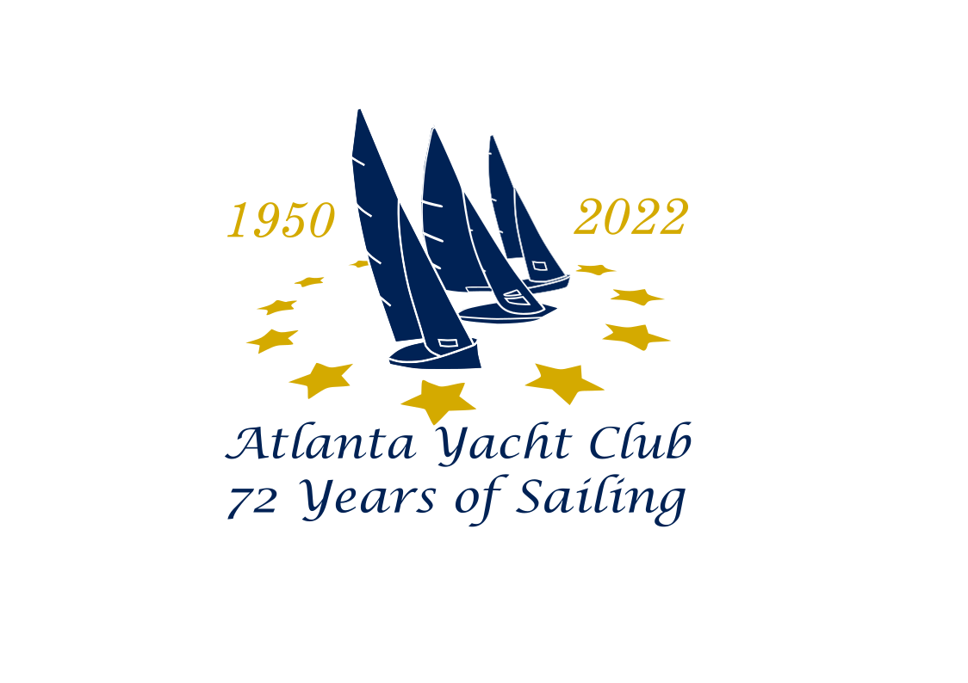**NOTICE OF RACE (NOR)**



***EC-12***

***REGION 3 CHAMPIONSHIP***

***&***

***GONE WITH THE WIND REGATTA***

**09-10 April 2022**

**Organized by AMYC Fleet 47 and hosted by Atlanta Yacht Club**

**7120 Yacht Club Drive, Acworth, GA 30102**

|  |  |
| --- | --- |
| **1.0** | **Rules:** |
| 1.1 | The Regatta will be governed by the rules as defined in The Racing Rules of Sailing as modified by Appendix E. |
| 1.2 | The US Sailing Prescription to rule 60.3 is deleted. |
| 1.3 | The EC12 Class Rules |
| **2.0** | **Eligibility:** |
| 2.1 | Skippers shall be a member of the AMYA or, in the case of international entries, a member of your national sailing authority. The boat entered must be properly registered with the class and be certified. |
| 2.2 | Boat measurement certificates are required and shall be available if requested. |
| **3.0** | **Entry:** |
| 3.1 | **Entry fee is $45**. *Please pay by Friday 25 March*. Fee includes Friday night welcome party, Saturday and Sunday continental breakfasts, Saturday and Sunday lunches, plus Saturday after the race social and Saturday dinner. |
| 3.2 | An extra Guest Meal package is $30 (Dinner only is $10). Extra guest meal package includes Friday night welcome party, Saturday and Sunday continental breakfasts, Saturday and Sunday lunches, Saturday *after the race* social and Saturday dinner. |
| 3.3 | Competitors may enter by either registering on the AMYA web site, using PAYPAL ([2804412@gmail.com](mailto:2804412@gmail.com)) or VENMO (<https://venmo.com> *@RebelRd, (4 digit phone – 1554) include your Name and Gone With The Wind in the Venmo Notes*) to pay the $45 entry fee plus guest fees **OR** by mailing an Entry Form with a $45 entry fee, and any Guest fees, to be received no later than Friday, March 25, payable to Ian Elliott, 5000 Streamview Court, Woodstock, GA 30189 |
| **4.0** | **Racing Format** |
| 4.1 | If more than 18 boats compete, racing will be conducted under the Equal Opportunity Racing System (EORS); otherwise, all boats will start together as one fleet. |
| 4.2 | The current National Seeding List will be used if heats are sailed. |
| **5.0** | **Control Area** |
| 5.1 | AYC Beach (same as 2019). |
| **6.0** | **Sailing Instructions (SIs)** |
| 6.1 | Sailing Instructions will be available at Registration. |
| **7.0** | **Scoring** |
| 7.1 | The Low Point Scoring System, as set forth by appendix A of the RRS, will apply. One (1) Throw out score, excluding penalty points, will be deducted from each Skippers’ overall score for every 8 races sailed. |
|  |  |
| **8.0** | **Schedule** |
| 8.1 | |  |  |  | | --- | --- | --- | | **Friday 08 April** | |  | | 1700-1800 | Registration | AYC Clubhouse | | 1800-1900 | Welcome Party, complimentary beer, wine, & soda | AYC Clubhouse | | 1900-2000 | Heavy Hors d’oeuvres, BYOB | AYC Clubhouse | | **Saturday 09 April** | |  | | 0800-0900 | Continental Breakfast and Registration | AYC Clubhouse | | 0915 | Skippers’ Meeting | AYC Barbeque Pavilion | | 0930 | First Race | Beach | | 1230-1315 | Lunch | AYC Clubhouse | | 1315 | Racing Resumes. No race to start after 1630 | Beach | | 1700 | After Race Party. Complimentary beer, wine soda | AYC Clubhouse | | 1900 | Dinner. BYOB | AYC Clubhouse | | **Sunday 10 April** | |  | | 0800-0900 | Continental Breakfast and Registration. | AYC Clubhouse | | 0915 | Skippers’ Meeting | AYC Barbeque Pavilion | | 0930 | First Race. No race to start after 1200 | Beach | | 1230 | Awards Presentation with Lunch to follow | AYC Clubhouse | |
|  |  |
| **9.0** | **Awards** |
| 9.1 | Awards will be presented to the top 5 Skippers |
| **10.0** | **“Sailing Safe”** |
| 10.1 | We highly encourage the use of “bow bumpers” but they are not mandatory for racing in this regatta |
| **11.0** | **Accommodations** |
| 11.1 | We have secured a block of rooms, at a discount, for the following motels near the Yacht Club – less than 5 miles away. **When booking room, reference “*Gone With The Wind******Regatta*” at Atlanta Yacht Club.** |
| 11.2 | |  |  |  |  | | --- | --- | --- | --- | | 1 | **Hampton Inn – Acworth**  1320 Hwy 92, Acworth, GA 30102 | 678-505-4870  *need to book before 03/18 | $139.00 + tax | |  | (5) Rooms reserved w/ (2) Queens, Fridge & Microwave / (5) Rooms reserved w/ King, Fridge & Microwave | | | |  |  |  |  | | 2 | **Holiday Inn Express Suites**  200 Northpoint Way, Acworth, GA 30102 | 678-574-4222 | $139.00 + tax | |  |  |  |  | | 3 | **Days Inn – Wyndham**  164 Northpoint Way, Acworth, GA 30102 | 770-975-9000 | $85.00 + tax | |
| **12.0** | **More Information** |
| 12.1 | Contact Ian Elliott, Regatta Chairman, at 678-595-9315 , or email 2804412@gmail.com |
| **Note**: *The Atlanta Yacht Club gate will be placed on automatic for the Regatta. Drive your car up to the closed gate and it will open to allow one car to pass at a time. Drive through and the gate will close behind you. DO NOT tailgate the car in front of you as the gate may close on your car and cause damage.* | |
| **AYC PROHIBITS FIREARMS, PETS AND MOTORCYCLES ON CLUB PREMISES**  **IT IS THE RESPONSIBILITY OF AYC MEMBERS & GUESTS TO TAKE APPROPRIATE MEASURES TO SAFEGUARD THEIR PERSONAL PROPERTY WHILE ON CLUB PREMISES** | |

