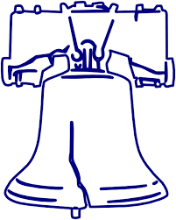

49th Annual Liberty Bell Regatta

Sunday, April 3, 2022

Sponsors: The Mid-Atlantic Model Yacht Club. AMYA Sanctioned Club #24

Rules: The regatta will be governed by the Racing Rules of Sailing for 2021-2024, as amended by the United States Sailing prescriptions and incorporating Appendix E-Radio Controlled Boat Racing Rules, and further sailing instructions as mandated by the Race Director (RD) during the course of the sailing day by announcing the changes.

Venue: Laurel Acres Park, 1045 South Church Street, Mount Laurel, New Jersey.

Entries: Limited to 24 boats (due by March 28, 2022).
Entry fee: $28 includes lunch, sodas & water, awards

Eligibility: The regatta is open to all skippers with boats registered with the EC-12 Class and current members of AMYA.

Registration: https://form.jotform.com/220166787608161

Format/Scoring: Sailing Instructions will be distributed on race day. We will be sailing the CESS Pool System of race management if over 20 boats. A boat's worst score will be excluded for the day. A Second worst score will be excluded if 12 or more races are sailed.

Schedule: Sunday, April 3, 2022
Skippers Meeting 9:30 am
Racing Begins 10:00 am
Lunch Break Mid-Day
Final Race no later than 4:00pm
Awards Immediately after scores are tabulated

Questions: Dave Branning, laserdave93@yahoo.com; 410-353-3637
Ray Szulczewski, tiderun1@aol.com; 609-410-7899

